**Q1.**When two objects interact, they exert forces on each other.

(a)     Which statement about the forces is correct?

Tick (✓) **one** box.

|  |  |  |
| --- | --- | --- |
|  |  | **Tick (✓)** |
|  | The forces are equal in size and act in the same direction. |  |
|  | The forces are unequal in size and act in the same direction. |  |
|  | The forces are equal in size and act in opposite directions. |  |
|  | The forces are unequal in size and act in opposite directions. |  |

**(1)**

(b)     A fisherman pulls a boat towards land.

The forces acting on the boat are shown in **Diagram 1**.

The fisherman exerts a force of 300 N on the boat.  
The sea exerts a resistive force of 250 N on the boat.

**Diagram 1**



(i)      Describe the motion of the boat.

................................................................................................................

................................................................................................................

................................................................................................................

**(2)**

(ii)     When the boat reaches land, the resistive force increases to 300 N.  
The fisherman continues to exert a force of 300 N.

Describe the motion of the boat.

Tick (✓) **one** box.

|  |  |  |
| --- | --- | --- |
|  | Accelerating to the right |  |
|  | Constant velocity to the right |  |
|  | Stationary |  |

(iii)    Explain your answer to part **(b)(ii)**.

................................................................................................................

................................................................................................................

................................................................................................................

................................................................................................................

**(2)**

**(Total 6 marks)**

**Q2.**(a)    The diagram shows two forces acting on an object.



What is the resultant force acting on the object?

Tick ( ) **one** box.

|  |  |  |
| --- | --- | --- |
|  | 8 N to the right |  |
|  | 8 N to the left |  |
|  | 4 N to the right |  |
|  | 4 N to the left |  |

**(1)**

(b)     BASE jumpers jump from very high buildings and mountains for sport.

The diagram shows the forces acting on a BASE jumper in flight.  
The BASE jumper is wearing a wingsuit.

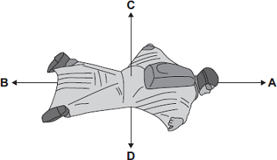

(i)      Draw a ring around the correct answer in the box to complete each sentence.

|  |  |  |  |
| --- | --- | --- | --- |
|  |  | smaller than |  |
|  | The BASE jumper accelerates forwards when force **A** is | equal to | force **B**. |
|  |  | bigger than |  |

|  |  |  |  |
| --- | --- | --- | --- |
|  |  | smaller than |  |
|  | The BASE jumper falls with a constant speed when force **C** is | equal to | force **D**. |
|  |  | bigger than |  |

**(2)**

(ii)     To land safely the BASE jumper opens a parachute.

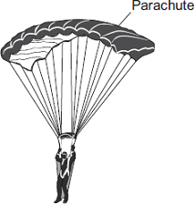

What effect does opening the parachute have on the speed of the falling BASE jumper?

...............................................................................................................

Give a reason for your answer.

...............................................................................................................

...............................................................................................................

**(2)**

**(Total 5 marks)**